**Pic Stefan:**

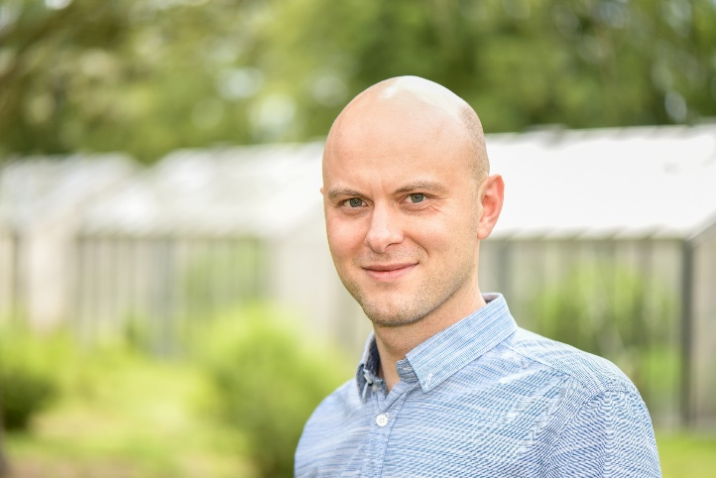

**Bio:** Stefan is since 2016 at the IPK Gatersleben head of the independent research group Meiosis currently funded by the ERC focusing on plant meiosis that generates genetic variation harnessed during plant breeding. Before he was research fellow at the University of Birmingham, UK, in the group of Chris Franklin working on plant meiotic recombination and he received his PhD in 2013 from Martin-Luther-University Halle-Wittenberg for his work on centromeres in mono‐ and holocentric chromosome plants performed under supervision of Andreas Houben at the IPK Gatersleben.